K. E. Society's

# **RAJARAMBAPU INSTITUTE OF TECHNOLOGY**

**(POLYTECHNIC) LOHAGOAN, PUNE**

Tal. Haveli, Dist. Pune 411 047

**Year 2024-25**



A

Micro Project Report

On

**“microprosser”**

Submitted in partial fulfillment of the requirements for

Diploma in AIML ENGINEERING

Of

**M.S.B.T.E., MUMBAI**

**By**

|  |  |  |  |  |
| --- | --- | --- | --- | --- |
| Sr.No. | Name | Middle | Surname | Roll.No |
| **1** | **Tushar** | **Bhagwat** | **Rathod** | **69** |
| **2** | **Darshan** | **Sachin** | **Gadekar** | **68** |
| **3** | **vaishnavi** | **Mahesh** | **Ghadamode** | **67** |

UNDER THE GUIDANCE Of

**Mrs.Shweta Kolapkar**

K. E. Society's

## RAJARAMBAPU INSTITUTE OF TECHNOLOGY (POLYTECHNIC) LOHAGOAN, PUNE

**Year 2024-25**



CERTIFICATE

|  |  |  |  |  |
| --- | --- | --- | --- | --- |
| Sr.No. | Name | Middle | Surname | Roll.No |
| **1** | **Tushar** | **Bhagwat** | **Rathod** | **69** |

This is to certify that **Rathod Tushar Bhagwat** Student of **Rajarambapu Institute Of Technology (Polytechnic) Lohagoan**, Pune have satisfactorily completed the Micro Project work on **“Write 8086 Assembly language program to find the HCF of two numbers stored at memory location 8000H and 8001H.”** in partial fulfillment of

Diploma in **AIML Engineering** of **Maharashtra State Board of Technical Education**, Mumbai during the academic year 2024-2025.

**Mrs. Shweta Kolapkar Mr. V. R. Saste Dr. K. H. Munde**

Guide HOD Principal

K. E. Society's

## RAJARAMBAPU INSTITUTE OF TECHNOLOGY (POLYTECHNIC) LOHAGOAN, PUNE

**Year 2024-25**



CERTIFICATE

|  |  |  |  |  |
| --- | --- | --- | --- | --- |
| Sr.No. | Name | Middle | Surname | Roll.No |
| **3** | **vaishnavi** | **Mahesh** | **Ghadamode** | **67** |

This is to certify that **Ghadamode Vaishnavi Mahesh** Student of **Rajarambapu Institute Of Technology (Polytechnic) Lohagoan**, Pune have satisfactorily completed the Micro Project work on **“Write 8086 Assembly language program to find the HCF of two numbers stored at memory location 8000H and 8001H.”** in partial fulfillment of

Diploma in **AIML Engineering** of **Maharashtra State Board of Technical Education**, Mumbai during the academic year 2024-2025.

**Mrs. .Shweta Kolapkar Mr. V. R. Saste Dr. K. H. Munde**

Guide HOD Principal

K. E. Society's

## RAJARAMBAPU INSTITUTE OF TECHNOLOGY (POLYTECHNIC) LOHAGOAN, PUNE

**Year 2024-25**



CERTIFICATE

|  |  |  |  |  |
| --- | --- | --- | --- | --- |
| Sr.No. | Name | Middle | Surname | Roll.No |
| **2** | **Darshan** | **Sachin** | **Gadekar** | **68** |

This is to certify that **Gadekar Darshan Sachin** Student of **Rajarambapu Institute Of Technology (Polytechnic) Lohagoan**, Pune have satisfactorily completed the Micro Project work on **“data communication in computer network”** in partial fulfillment of

Diploma in **AIML Engineering** of **Maharashtra State Board of Technical Education**, Mumbai during the academic year 2024-2025.

**Mrs. Shweta Kolapkar Mr. V. R. Saste Dr. K. H. Munde**

Guide HOD Principal

### ACKNOWLEDGEMENT

We take this opportunity to thank all those who have contributed in successful completion of this micro project work. We would like to express our sincere thanks to our guide**,** who has encouraged us to work on this topic and valuable guidance wherever required.

We wish to express our thanks to **Vikramsinh Saste**, Head of Dept. &

**Dr. K. H. Munde,** Principal, R.I.T.P., for their support and the help extended.

Finally, we are thankful to all those who extended their help directly or indirectly in preparation of this report.

|  |  |  |
| --- | --- | --- |
| **Sr. No.** | **Title** | **Page No.** |
| 1. | Abstract |  |
| 2. | Introduction |  |
| 3. | Features |  |
| 4. | Advantages |  |
| 5. | Disadvantages |  |
| 6. | Application |  |
| 7. | Rewilding Urban Areas for Bio-Diversity |  |
| 8. | Conclusion |  |

### INDEX

Write 8086Assembly language program to find the HCF of two numbers stored at memory location 8000H and 8001H.

1. Practical Outcome: Finding HCF using 8086 Assembly

• Store two numbers at memory locations 8000H and 8001H.

• Execute the program on an 8086 microprocessor emulator (e.g., MASM, TASM, or Emu8086).

• Observe the final value at memory location 8002H.

• The stored value should be the correct HCF of the two numbers.

1. **Unitoutcomes inCognitivedomain:**

• Knowledge (Remembering)

• Comprehension (Understanding)

• Application (Applying)

• Analysis (Analyzing)

• Synthesis (Creating)

• Evaluation (Evaluating)

1. **OutcomesinAffectivedomain:**

**Receiving (Awareness & Willingness to Learn)**

• Responding (Active Participation & Engagement)

• Valuing (Appreciation & Ethical Use of Knowledge)

• Organization (Prioritization & Integration of Learning)

• Characterization (Internalization & Lifelong Learning)

8086 Assembly language program to find the HCF of two numbers stored at memory location 8000H and 8001H.

Program code:

.MODEL SMALL

.STACK 100H

.DATA

MSG1 DB 'Enter first number:$'

MSG2 DB 'Enter second number:$'

MSG3 DB 'HCF = $'

NUM1 DB ? ; First number (will be loaded from memory location 8000H)

NUM2 DB ? ; Second number (will be loaded from memory location 8001H)

HCF DB ? ; Variable to store the HCF

.CODE

MAIN PROC

MOV AX, 8000H ; Load the address of the first number (8000H) into AX

MOV DS, AX ; Set DS to point to the memory segment containing the numbers

MOV SI, 0 ; Set SI to 0 (offset for memory access)

MOV AL, [SI] ; Load the first number (from 8000H) into AL

MOV NUM1, AL ; Store the first number in NUM1

INC SI ; Increment SI to point to the next memory location (8001H)

MOV AL, [SI] ; Load the second number (from 8001H) into AL

MOV NUM2, AL ; Store the second number in NUM2

; Euclidean Algorithm to find HCF

MOV AL, NUM1 ; Load NUM1 into AL

MOV BL, NUM2 ; Load NUM2 into BL

FIND_HCF:

CMP AL, BL ; Compare AL and BL

JE HCF_FOUND ; If AL == BL, HCF is found

JA GREATER ; If AL > BL, jump to GREATER

SUB BL, AL ; If AL < BL, subtract AL from BL

JMP FIND_HCF ; Repeat the process

GREATER:

SUB AL, BL ; Subtract BL from AL

JMP FIND_HCF ; Repeat the process

HCF_FOUND:

MOV HCF, AL ; Store the HCF in the HCF variable

; End of program

MOV AH, 4CH ; Terminate program

INT 21H

MAIN ENDP

END MAIN

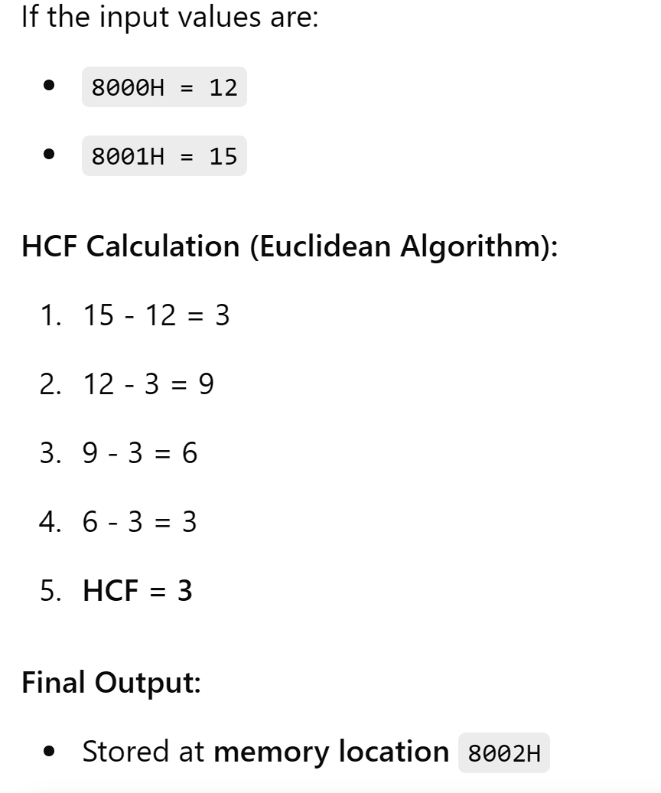

**Course Title and Code: - Microprocessor [314321]**

**Title of the Project: - Write 8086 Assembly language program to find the HCF of two numbers stored at memory location 8000H and 8001H.**

**COs addressed by the Micro Project:**

|  |  |  |
| --- | --- | --- |
| **CO 1** | **:** | Analyze the functional block diagram of 8086 microprocessor |
| **CO 2** | **:** | Use program development tools and assembler directives. |
| **CO 3** | **:** | Use instructions in different addressing modes. |
| **CO 4** | **:** | Develop an assembly language program for a given task using assembler. |
| **CO 5** | **:** | Use procedures and macros to develop an assembly language program for a given problem. |

**Marks:-**

|  |  |  |  |  |
| --- | --- | --- | --- | --- |
| **Roll No.** | **Name Of Student** | **Marks for**  **Individual work**  **(06)** | **Marks obtained by the**  **individual**  **based on viva**  **(04)** | **Total**  **Marks**  **(10)** |
| 69. | Rathod Tushar Bhagwat |  |  |  |
| 68. | Gadekar Darshan Sachin |  |  |  |
| 67. | Ghadamode Vaishnavi Mahesh |  |  |  |

**Name and designation of Faculty Member**: **Mrs.Shweta Kolapkar**

**Signature:**